Guidelines of Paper Preparation for RMEGV2021

First A. Authorª* and Second B. Author^{b}

ª Rock Mechanics University, Fukuoka, Japan
^{b}Engineering Geology Ltd., Roma, Italy
* first.author@rmegv2021.jp (corresponding author’s E-mail)

Abstract

This article serves as the template of the proceedings paper (final manuscript) for your abstract submitted to the 5th Workshop on Rock Mechanics and Engineering Geology in Volcanic Fields (RMEGV2021). Please use this template when preparing your proceedings paper. This will ensure a uniform format in the publication. The proceedings paper should be written in English and submitted as this MS Word file format and PDF file (in camera-ready form and matching the template for submission). The proceedings paper should begin with

- Title: Please provide a descriptive title of the proceedings paper. The title should be concise and not span more than 2 lines. Use Times New Roman font with a font size of 14 pts and in bold face for the title.
- Authors and affiliations: Include the first name, middle initial and surname of all the authors. The affiliations of all the authors should be included. The e-mail of the corresponding author should be shown.
- Abstract: Not more than 350 words.
- Keywords: Provide up to 5 keywords, separated by commas. The first letter of each word should be capitalized.
- All the above contents (i.e., title, authors’ names, affiliations, abstract, and keywords) MUST be included within the first page.

The subsequent pages should include numbered sections of Introduction, Theories (or Experiments), Results and Discussion, Conclusions, Acknowledgement, and References. Throughout the proceedings paper, use Times New Roman font with single spacing between lines. The recommended font size is 14 pts for the title and 11 pts elsewhere. The main text should be justified on both sides. The use of footnotes is discouraged. The numbers of pages of the paper shall be between 4 and 6.
The files of the proceedings paper must be submitted before May 31, 2021 via the workshop website.
Authors who are not themselves native English speakers may need to take particular care to ensure that their manuscript are clear and grammatically correct. Then it is highly recommended that proceedings paper is checked by a native English speaker before submission.

Keywords: Rock Mechanics, Engineering Geology, Volcanic field, Slope Stability, Permeability

- Introduction
RMEGV2021 will be held in Fukuoka, Japan during September 9 - 11, 2021. The themes of this workshop include volcanic geology, disasters and their mitigation, resources and energy in volcanic fields, mechanical behavior of volcanic rocks and soils, groundwater and environmental problems in volcanic fields, and geotechnical engineering in volcanic fields. The goals of this workshop are to promote the exchange of ideas and information among civil engineers and geologists regarding serious issues related to volcanic fields, and to find possible solutions to them, as well as to aid in the fusion of Civil Engineering and Geology in terms of applied volcanic science, including construction, environment, groundwater, disasters, and geothermal energy.

- Methodology
2.1 Citation, tables and figures
Sub-titles are allowed in each section. In the text, the references should be cited in the author-year format, e.g., (Author, 1986), (Author 1 and Author 2, 1997), (Author 1 et al., 2003), (Author 1, 2006; Author 2, 2010), (Author, 2003a; 2003b; 2010). The list of references should be placed at the end of the proceedings paper in the alphabetical order. The equations should be justified at the center and the equation numbers in parenthesis should be justified on the right side as Eq. (1).
(1)
The tables and figures should be numbered in sequence and captioned as shown in Table 1 and Fig.1. The followings are the examples for a table and a figure.

Table 1 Porosity, water content and water saturation ratio of Berea sandstone.
Porosity (%) | Case | Water content |  | Water saturation ratio (%)
 |  | (mass %) | (vol %)
20.1 | (a) | 0.15 | 0.27 | 1
 | (b) | 3.00 | 5.40 | 23
 | (c) | 6.00 | 10.8 | 45

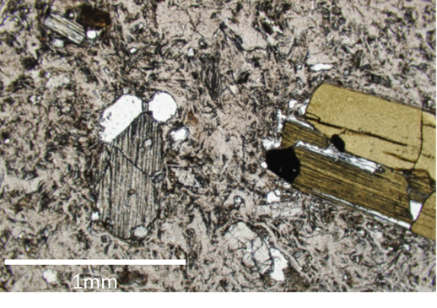
Fig. 1. Photomicrograph of welded tuff.

- Conclusions
We are looking forward to receiving your proceedings paper. For any questions about the guidelines, please contact RMEGV2021 registration office at rmegv2021@rocknet-japan.org.

Acknowledgements
The Organizing Committee greatly appreciates your contribution to make the workshop fruitful and exciting.

References
Evansa, S. G., Hungrb, O. and Clague, J. J., 2001, Dynamics of the 1984 rock avalanche and associated distal debris flow on Mount Cayley, British Columbia, Canada; implications for landslide hazard assessment on dissected volcanoes, Eng. Geol., 61, 29-51.
Miyabuchi, Y., Maeno, F. and Nakada, S., 2015, The October 16, 2013 rainfall-induced landslides and associated lahars at Izu Oshima Volcano, Japan, J. Volcanol. Geotherm. Res., 302, 242-256.
Orense, R.P. and Pender, M.J., 2016, From micro to macro: An investigation of the geomechanical behaviour of pumice sand, Volcanic Rocks and Soils (Rotonda et al. eds), Proceedings of the international workshop on volcanic rocks and soils, Lacco Ameno, Ischia Island, Italy, 24-25, September 2016, 45-62.

